Austo Analytics Report
Austo Motor Company is a leading automobile manufacturer offering SUVs, Sedans, and Hatchbacks. The company aims to improve the efficiency of its current marketing campaign by leveraging customer data. This report presents a detailed exploratory and relational analysis of the dataset to derive actionable business insights in a clear and non-technical manner.
The instructions below are given to help you complete the project –

1.What is the important technical information about the dataset that a database administrator would be interested in? (Hint: Information about the size of the dataset and the nature of the variables)
Solution:-
This data is about the Austo Motor Company is a leading in specializing in SUV, Sedan and Hatchback models. Below are some important Technical information about the dataset:

- The data set contain of 1581 rows & 14 columns.
- The dataset contain 5 integer ,1 Float & 8 Object datatype columns.

S.no | Columns | Data Type
1 | Age | Int64
2 | Gender | Object
3 | Profession | Object
4 | Marital_status | Object
5 | Education | Object
6 | No_of_Dependents | Int64
7 | Personal_loan | Object
8 | House_loan | Object
9 | Partner_working | Object
10 | Salary | Int64
11 | Partner_salary | Float64
12 | Total_salary | Int64
13 | Price | Int64
14 | Make | object

2.Take a critical look at the data and do a preliminary analysis of the variables. Do a quality check of the data so that the variables are consistent. Are there any discrepancies present in the data? If yes, perform preliminary treatment of data.

Solution:-
After a Preliminary review of the data set we notice following discrepancies
- Unique value in the object data type
Columns | Data Types | Unique Values
Gender | Object | Male,Femal,Femle,Female,nan
Profession | Object | Business,Salaried
Marital_status | Object | Married,Single
Education | Object | Post Graduate,Graduate
Personal_loan | Object | No,Yes
House_loan | Object | No,Yes
Partner_working | Object | No,Yes
Make | Object | SUV,Sedan,Hatchback

- During data quality checks, inconsistencies were observed in the Gender variable, where multiple representations such as Female, female, and Femle were present.

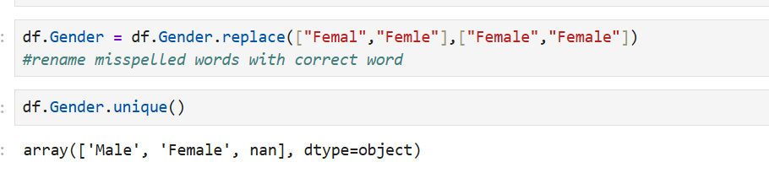

- After checking for the null value there are two columns found the null value “Gender” and “Partner_salary”.
- In “Gender” column = 53 Nulls value found & In the “Partner_Salary” column = 106 Nulls value found
- Since missing values can affect the accuracy of analysis and visualizations, appropriate treatment was applied.
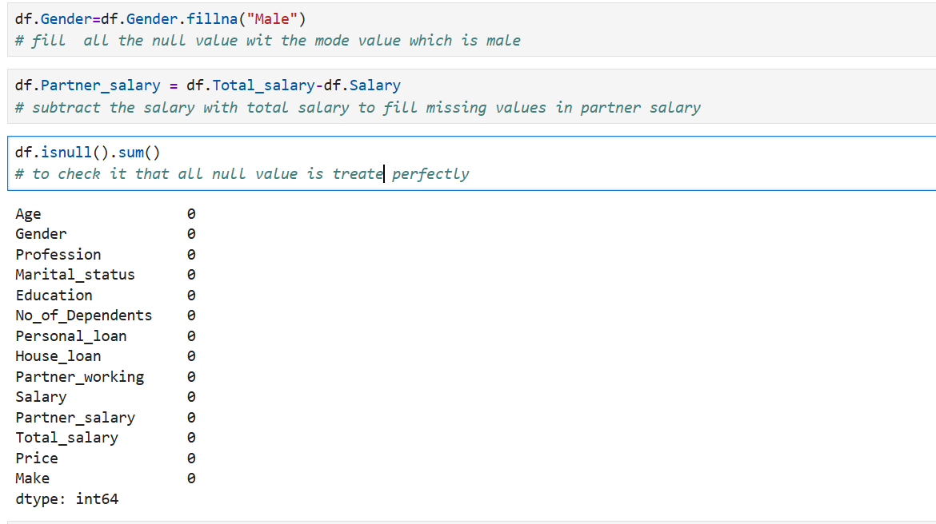

- The quantitative characteristics of the data is as follow ,this the data seems to be fine with no abonormalities

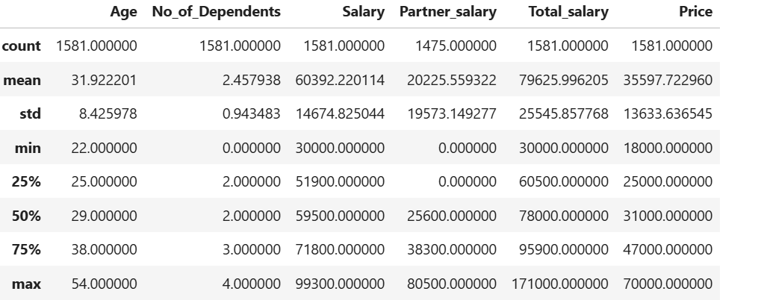

3. Explore all the features of the data separately by using appropriate visualizations and draw insights that can be utilized by the business.
Solution:-
To understand customer behavior, each variable in the dataset was analyzed individually
using appropriate visualizations.
Gender :-
Bar graph of Category “Gender”
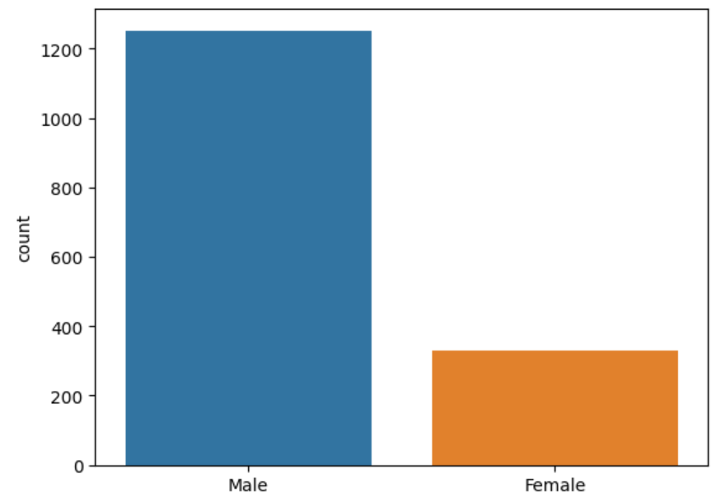
Observation:
The dataset shows that male customers form a larger proportion of automobile buyers compared to female customers. This suggests that current automobile purchases are male-dominated. However, the presence of female customers highlights an opportunity to increase female-focused marketing by emphasizing safety, comfort, and ease of use.
Profession:
Bar graph of Category “Profession ”
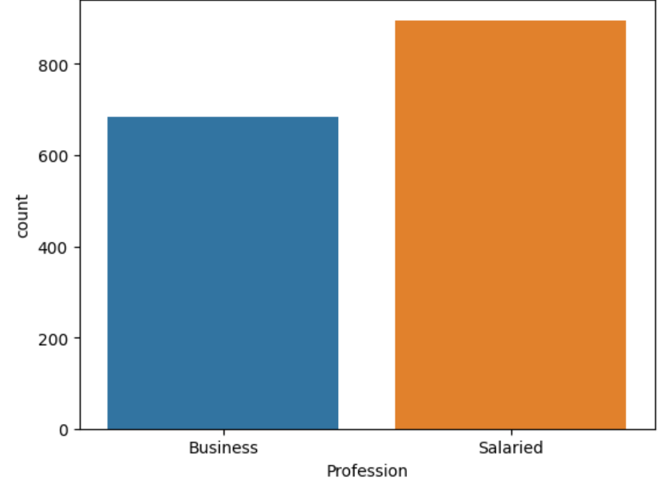
Observation:
The profession analysis indicates that salaried individuals dominate the customer base. This reflects a stable income group that is more likely to make planned and consistent purchasing decisions. This segment is ideal for structured financing and upgrade offers.
Marital Status:-
Bar graph of Category “Marital_status ”
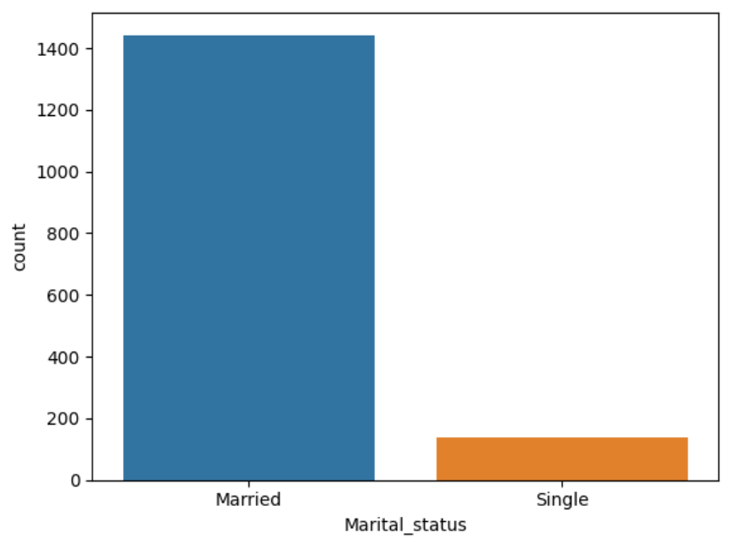Observation:
Most customers in the dataset are married. This suggests that vehicle purchase decisions are often influenced by family needs.
Education:-
Bar graph of Category “Education”
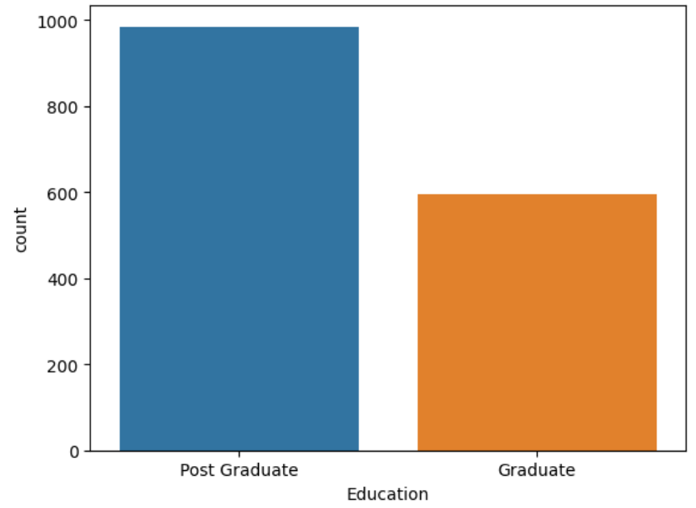
Observation:-
The education distribution shows that a significant portion of customers are postgraduates.

Personal_loan:-
Bar graph of Category “Personal Loan”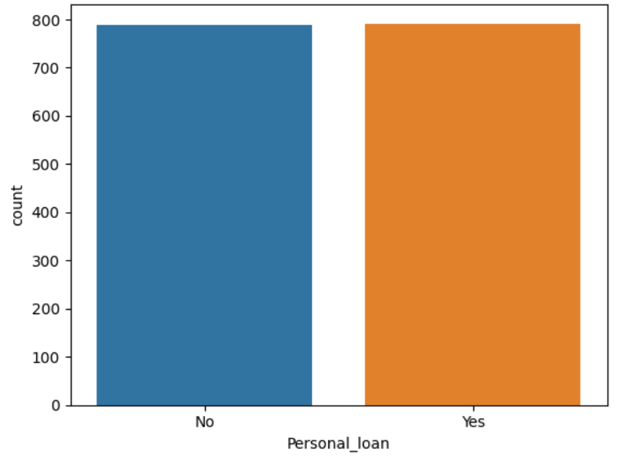
Obeservation:-
The personal loan distribution shows that customers are almost evenly split between those who have a personal loan and those who do not. This indicates that personal loan status is not a major barrier to vehicle purchase in this dataset.
House_loan:-
Bar graph of Category “House Loan”
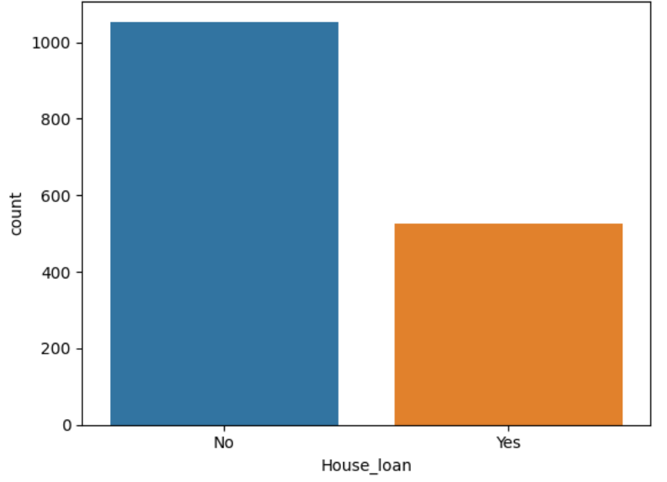
Observation:-
The house loan distribution shows that a significantly larger proportion of customers do not have an active house loan compared to those who do. Almost double

Partner_working:-
Bar graph of Category “Partner Working”
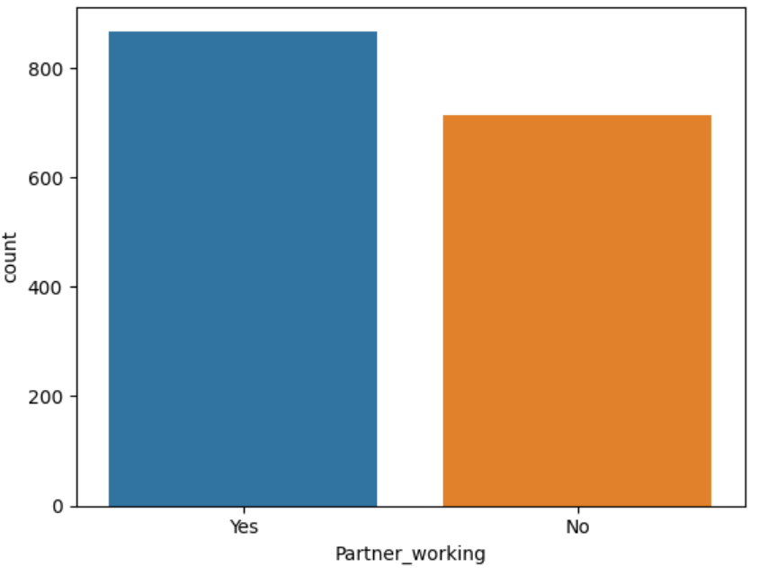
Observation:-
The distribution of the Partner Working variable shows that a considerable proportion of customers have a working partner.
Make:-
Bar graph of Category “Make”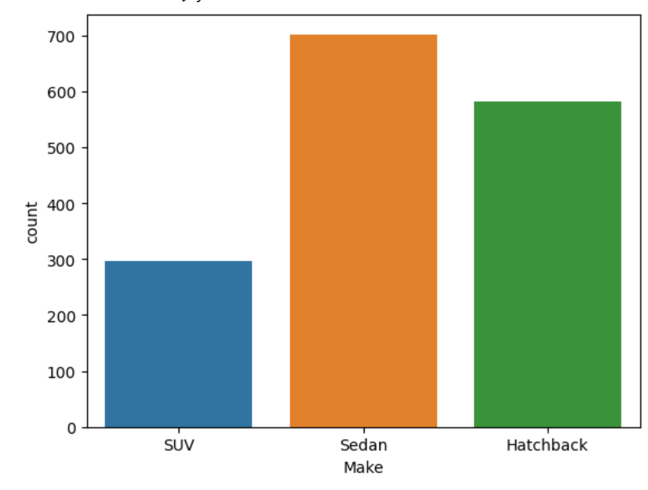
Observation:-
The distribution of vehicle type shows that Sedans have the highest number of purchases, followed by Hatchbacks with a small difference, while SUVs have the lowest share among the three categories. This indicates that customers in this dataset prefer practical and value-oriented vehicles over larger or premium models.

AGE:-
Hist graph of Numerical “AGE”
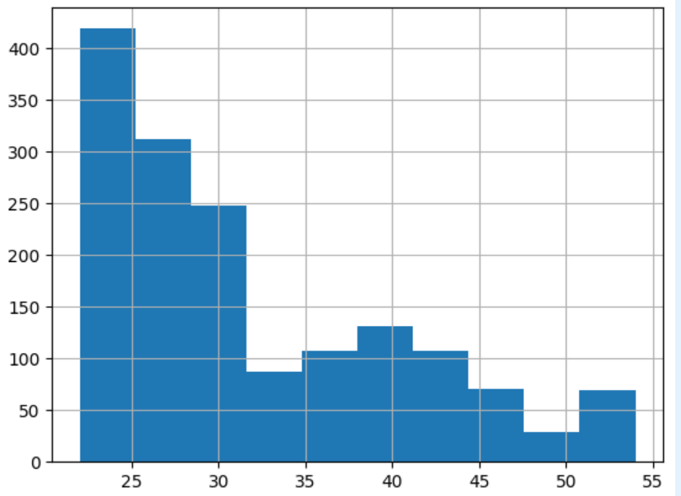
Observation:
Analysis of customer ages reveals that the majority fall within the 20–30 years range. This suggests that automobile purchases are predominantly made by young adults

No of Dependents:-
Hist graph of Numerical “No of Dependents”
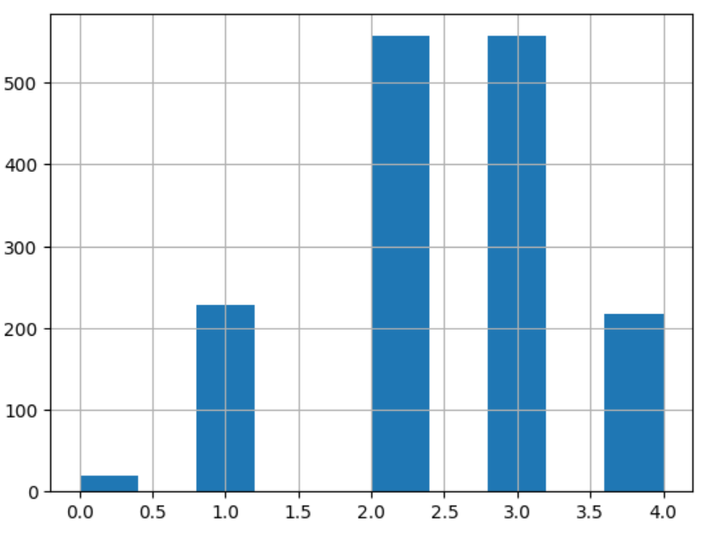
Observation:
There are more 500 peoples dependent on 2 and 3 category
There are almost 200 peoples with number of dependencies on 1 and 4 categories

Salary :-
Hist graph of Numerical “Salary”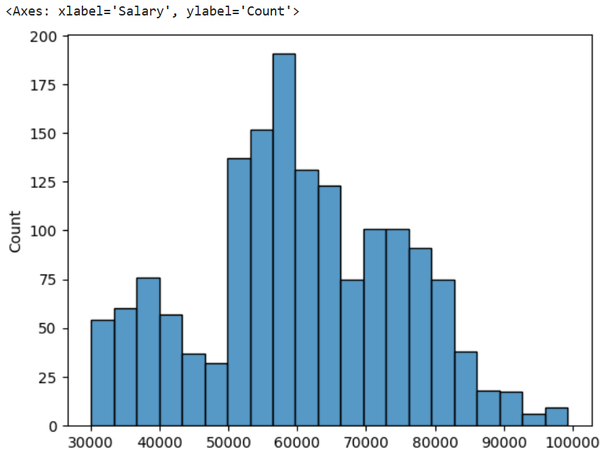
Observation:
- The salary distribution indicates that most customers earn between ₹50,000 and ₹70,000, with a noticeable peak around the mid-income range.
- This suggests that automobile purchases are most common among moderate to upper-middle income individuals, who likely have stable employment and sufficient purchasing power.
- Lower salary ranges (below ₹40,000) show comparatively fewer customers, while higher income levels (above ₹80,000) form a smaller but distinct segment.

Partner Salary :-
Hist graph of Numerical “Partner Salary”
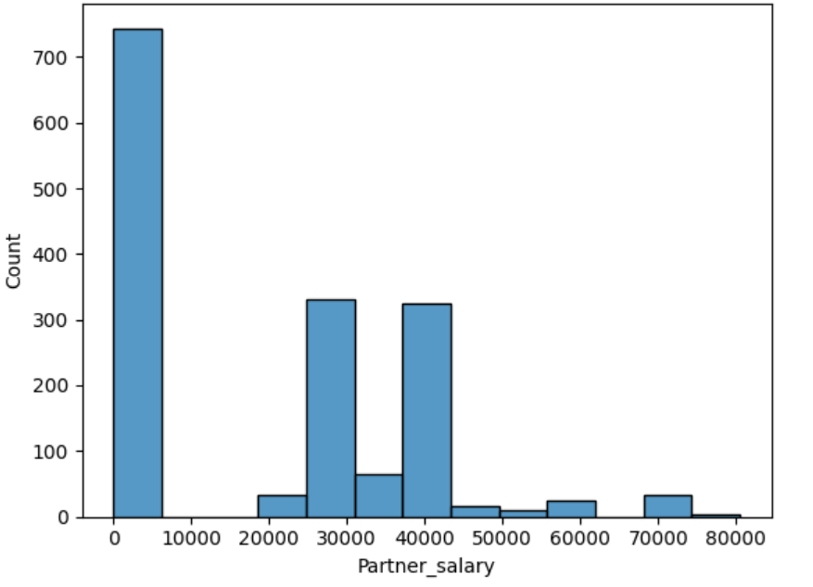
Observation:
- The partner salary distribution reveals a large number of zero or very low values, suggesting that many customers belong to single-income households or have non-working partners.
- Among working partners, salaries are mainly clustered between ₹25,000 and ₹40,000, with very few exceeding ₹60,000. This shows that partner income generally acts as a secondary support rather than a primary purchasing driver.

Total Salary :-
Hist graph of Numerical “Total Salary”
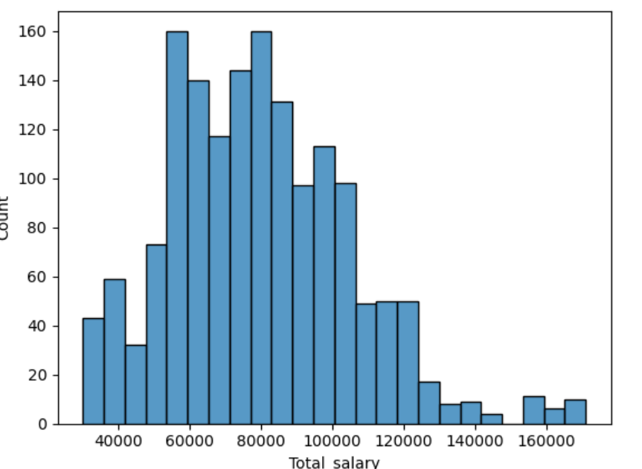
Observation:
- The total salary distribution indicates that most households fall within the ₹60,000 to ₹1,00,000 range, reflecting a moderate to upper-middle income customer base. The distribution is slightly right-skewed, with a smaller proportion of customers earning above ₹1,20,000, representing a premium segment.

4.Understanding the relationships among the variables in the dataset is crucial for every analytical project. Perform analysis on the data fields to gain deeper insights. Comment on your understanding of the data.
Solution:-
To understand the relationships between key variables in the dataset, bivariate and multivariate analyses were performed using appropriate visualizations. These analyses help uncover deeper patterns in customer behavior and purchasing decisions.

This graph show Vehicle Type Preference by Gender
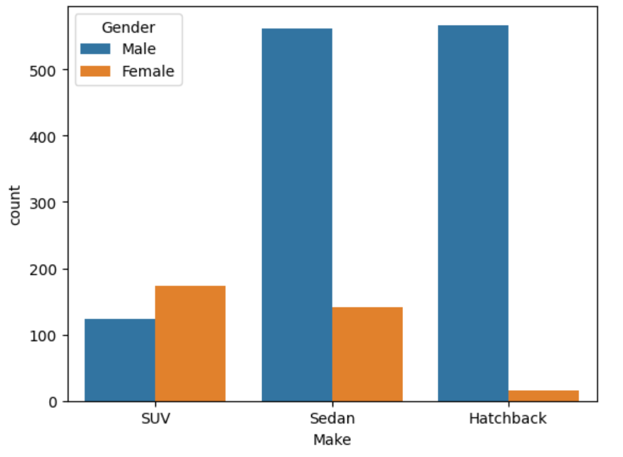
Observation:
- The analysis of vehicle type preference across gender shows clear differences in purchasing behavior. Male customers dominate purchases across all vehicle types, particularly in Sedans and Hatchbacks, where male buyers significantly outnumber female buyers. In contrast, female customers show their highest preference for SUVs, followed by Sedans, while Hatchback purchases among female customers are very low.
- This pattern indicates that gender plays an important role in vehicle selection. From a business perspective, Sedans and Hatchbacks can be primarily targeted toward male customers, while SUVs present a stronger opportunity for female-focused market.

2.Vehicle Type Preference by Profession

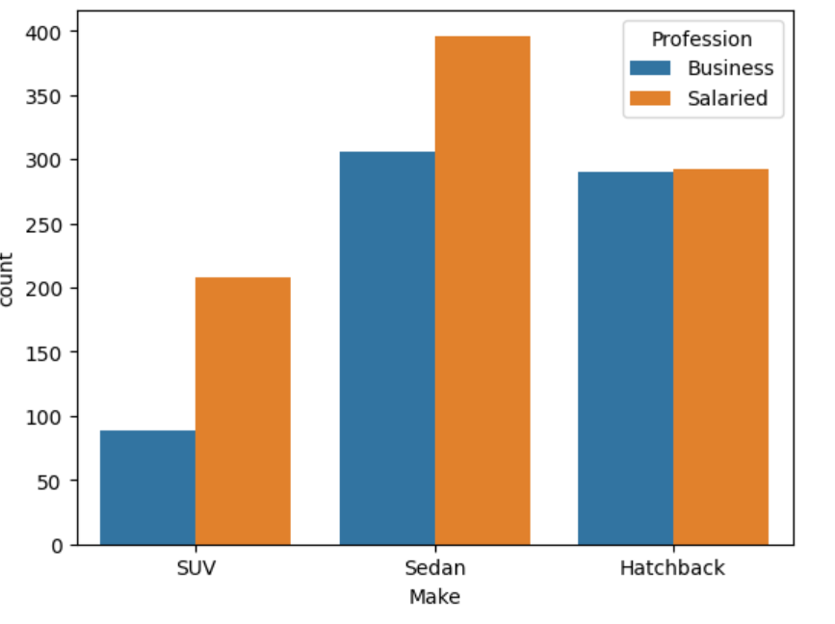
Obeservation:
The analysis of vehicle type preference by profession shows that salaried customers purchase more vehicles than business customers across all vehicle categories.
Sedans are the most preferred vehicle type for both salaried and business customers, with a noticeably higher count among salaried individuals.
Hatchbacks show nearly similar preference across both professions, while SUVs are the least preferred category, particularly among business customers.
Insight
From a business perspective, Sedans can be effectively marketed to salaried professionals, while Hatchbacks can be positioned as a practical option for both professional groups. SUVs may require targeted positioning or incentive-based campaigns to increase adoption.

Vehicle Type Preference by Marital Status
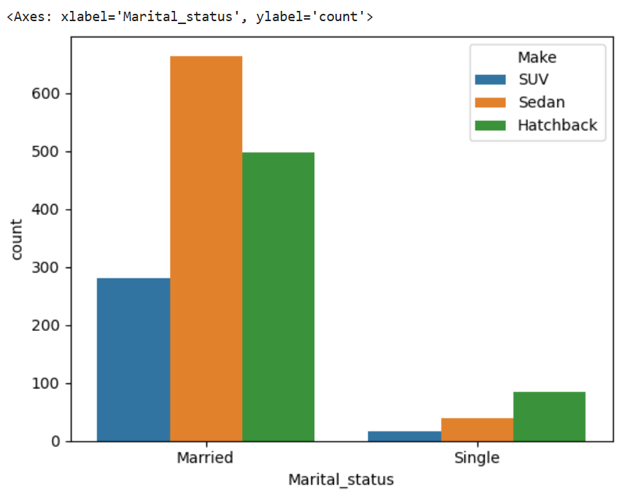

Obeservation:
The analysis of vehicle type preference by marital status shows that married customers account for the majority of vehicle purchases across all categories. Among married customers, Sedans are the most preferred vehicle type, followed by Hatchbacks, while SUVs have comparatively lower adoption. In contrast, single customers represent a much smaller share of purchases, with Hatchbacks being their most preferred option, followed by Sedans, and very limited SUV purchases.
Insight :
family-oriented marketing strategies can be effectively targeted toward married customers, while compact and budget-friendly vehicles may be better suited for single customers.

- Employees working on the existing marketing campaign have made the following remarks. Based on the data and your analysis state whether you agree or disagree with their observations. Justify your answer Based on the data available.

Solution 5:

E1: Steve Roger says “Men prefer SUV by a large margin, compared to the women”: Disagree: It is clearly visible from the bar graph that female is more interested and prefer more SUV than male
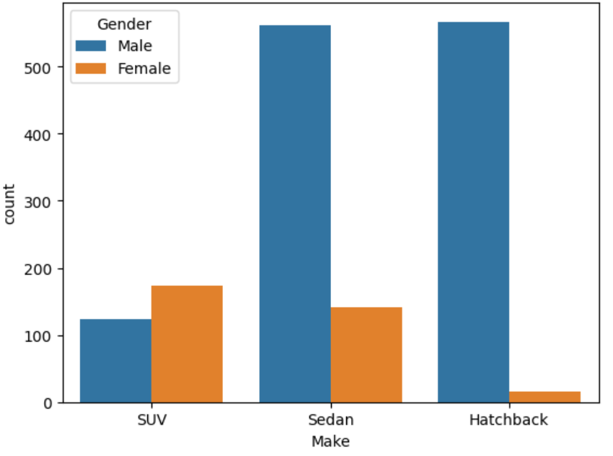

E2: Ned Stark believes that a salaried person is more likely to buy a Sedan. Agree; it is clearly visible from the bar graph that salaried person is more likely to buy a sedan.

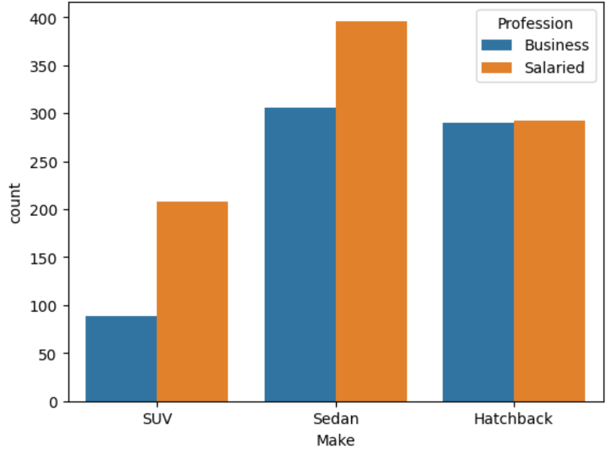

Agree; it is clearly visible from the bar graph that salaried person is more likely to buy a sedan

E3: Sheldon Cooper does not believe any of them; he claims that a salaried male is an easier target for a SUV sale over a Sedan Sale.
Disagree: It is clearly visible from the chart below that salaried males prefer.
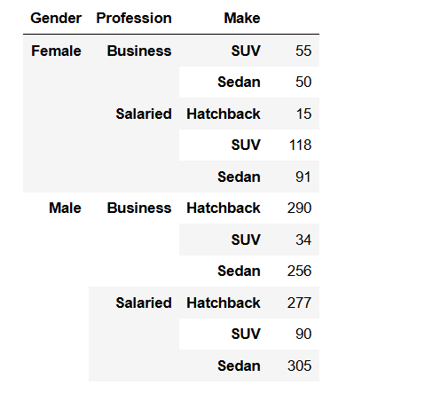
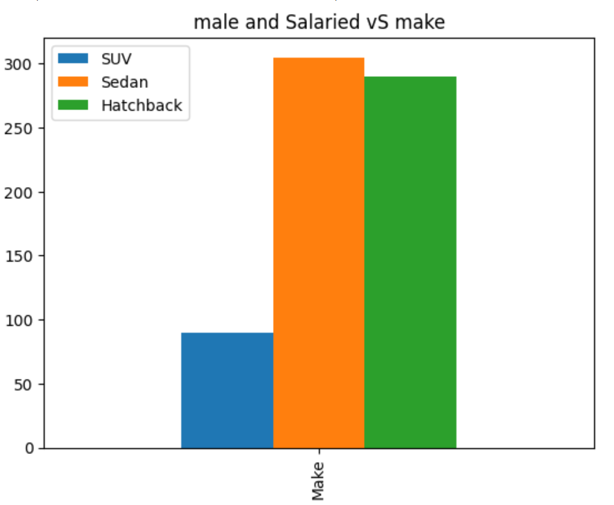
Disagree: It is clearly visible from the chart that salaried males prefer Sedan &Hatchback.

- From the given data, comment on the amount spent on purchasing automobiles across the following categories. Comment on how a Business can utilize the results from this exercise. Give justification along with presenting metrics/charts used for arriving at the conclusions.

F1) Gender
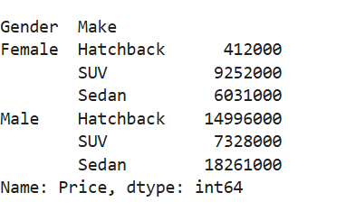



Observation:
- The amount spend on SUV by females is more than that spend my males
- The amount on Hatchback is more than triple compaired to amount spend by females
- The amount spend on Sedan is more almost triple,compaired to amount spend by females

6(i) Personal_loan

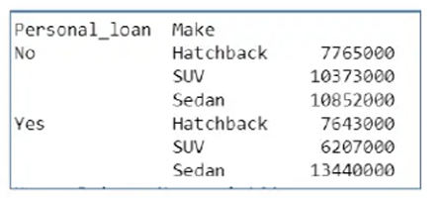

Observation:
- The amount spend on SUV and Sedan is more from buyers having no personal loan.
- The amount spent on Sedan is more from buyers having personal loan.
- The amount spent on SUV and Hatchback is less from buyers having personal loan.

- From the current data set comment if having a working partner lead to the purchase of a higher-priced car.
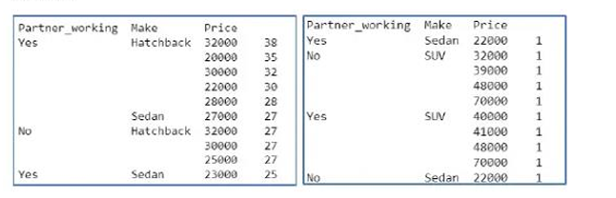
Observation: Yes From the current dataset provide the buyers having working partner tends to purchase car with higher price

- The main objective of this analysis is to devise an improved marketing strategy to send targeted information to different groups of potential buyers present in the data. For the current analysis use the Gender and Marital_status - fields to arrive at groups with similar purchase history.

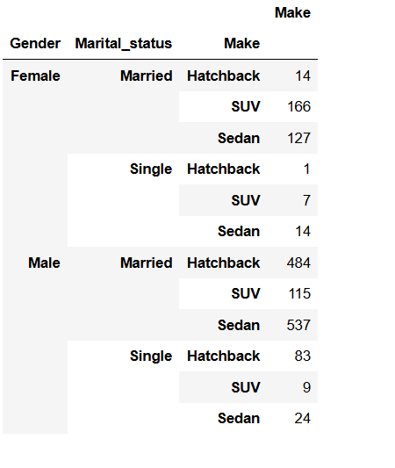
Observation:
- As married tends to buy more of Sedan and Hatchback may be due to budget constraints and other liabilities like personal loan and house loan. Multiple schemes can be provided to them discount on SUV. Which can come under their budget and its more spacious as per the family requirements.
- Single males tends to buy more of hatchback cars as compared to other two categories. Marketing strategies can be devised in a way to target only single males for increasing sales of hatchback cars
- Married females tend to buy more of SUV and Sedan as cars as compared to hatchback. Marketing strategy can be devised in a way to target only married females for increasing sales of SUV and Sedan.

